**Project Title: Traffic Management System**

**Phase 1: Project Definition and Design Thinking**

**Project Definition:**

The project titled "Traffic Management System" aims to enhance traffic management and reduce congestion in urban areas by leveraging IoT and data analytics. It involves the deployment of sensors and smart technologies to monitor and manage traffic flow, optimize signal timings, and provide real-time information to commuters before entering into the roads. The core objectives include improving traffic efficiency, reducing travel times, and minimizing environmental impact.

**1. Project Objectives:**

* Real-time Traffic Monitoring: Define the scope of traffic data collection, including vehicle counts, speeds, and congestion levels.
* Overcome time delay: Create a system that can help drivers beware of overcrowded roads before entering into it
* Commuter Information Access: Determine how commuters will access real-time traffic updates, whether through mobile apps, websites, or electronic signage.
* Safety Enhancement: Consider how the system can improve road safety through accident detection and emergency response coordination.

**2. IoT Device Design:**

* Identify the types and quantities of sensors required (e.g., traffic cameras, vehicle detectors).
* Plan sensor placement at critical intersections and road segments to ensure comprehensive traffic data collection.
* Choose power sources (e.g., solar, grid) for sustainability and assess maintenance needs.

**3. Traffic Management Platform:**

* Select the technology stack for building a centralized traffic management platform (programming languages, databases, cloud infrastructure).
* Design an intuitive user interface (UI) for traffic operators and a user-friendly interface for commuters.
* Develop data storage strategies, including historical traffic data archiving and ensuring data security.

**4. Integration Approach:**

* Decide on communication protocols and technologies for data transmission from sensors to the central platform.
* Develop data analytics and decision-making algorithms for traffic signal optimization and incident management.
* Plan for redundancy and failover mechanisms to ensure system reliability.

**5. Project Timeline and Milestones:**

Create a detailed timeline for project phases, such as sensor deployment, platform development, testing, and system rollout.

**6. Budget and Resources:**

* Estimate the project budget, including sensor costs, software development, infrastructure, and ongoing maintenance expenses.
* Identify the necessary resources, including traffic engineers, software developers, and data analysts.

**7. Regulatory and Environmental Considerations:**

* Investigate regulatory approvals and permits required for installing sensors and modifying traffic signal timings.
* Assess the environmental impact, including power consumption and waste management.

**8. Community Engagement:**

Explore ways to involve the community, such as seeking input on traffic priorities and providing channels for feedback.

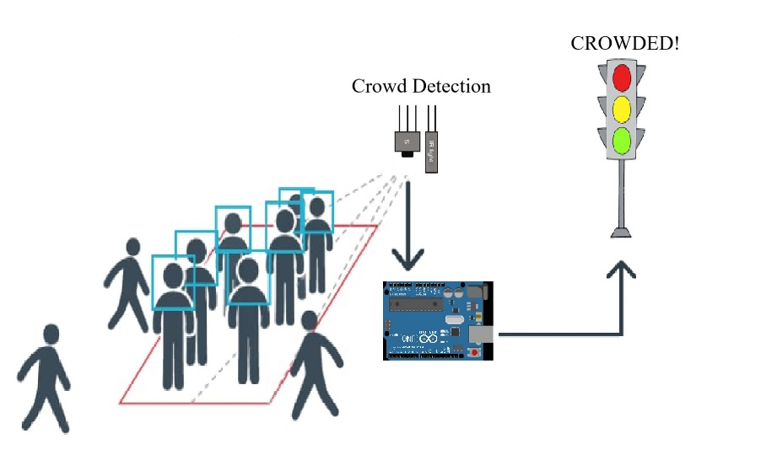

This comprehensive proposal outlines the key steps and considerations for implementing a Smart Traffic Management System to improve urban traffic conditions while considering environmental and community factors.